`

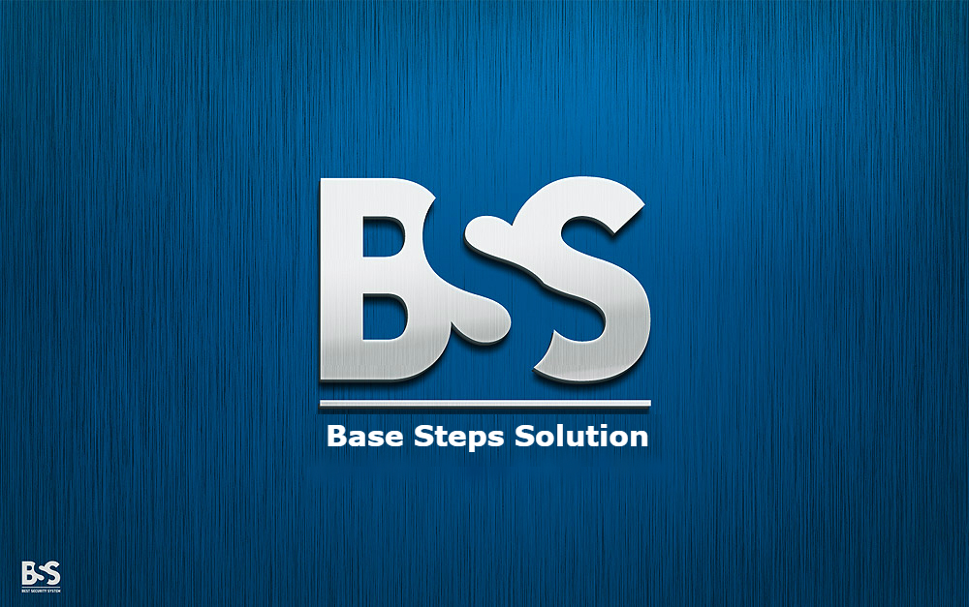

Change Management Plan

Van Lang Admissions

# Revision Table

|  |  |  |  |
| --- | --- | --- | --- |
| Author | Date | Reason for changes | Version |
| Minh Đoàn | 14/10/2016 | Initial Document | 1.0 |
| Xuân Thái Hiền, Minh Đoàn | 14/10/2016 | Update data | 1.1 |
| Minh Đoàn | 23/10/2016 | Update data and template | 1.2 |

Contents

Revision Table 1

1. INTRODUCTION 3

1.1. Purpose 3

1.2. Audience 3

1.3. Reference 3

2. Process 3

2.1. Process flow 3

2.2. Activities 4

3. Evaluating and Authorizing Change Request 5

3.1. Priority of change request 5

**Priority** 5

**Description** 5

High 5

Changes impact to process, cost, duration, time. 5

Medium 5

Changes impact to deliverables, product. 5

Low 5

Changes impact to resources, scope and quality. 5

3.2. Change request type 5

**Type** 5

**Description** 5

Scope 5

Change affecting scope 5

Time 5

Change affecting time 5

Duration 5

Change affecting duration 5

Cost 5

Change affecting cost 5

Resources 5

Change affecting resources 5

Deliverables 5

Change affecting deliverables 5

Product 5

Change affecting product 5

Processes 5

Change affecting process 5

Quality 5

Change affecting quality 5

4. Roles and Responsibilites 5

# INTRODUCTION

## Purpose

* This document is description about Change Management Plan. It introduces change management process and tools used to manage change in project.

## Audience

* The main audiences of this document are: Mentor, Base Steps Solution Team and may be customer of they need.

## Reference

BSS_ChangeRequestForm_V1.0

# Process

## Process flow



## Activities

|  |  |  |  |  |
| --- | --- | --- | --- | --- |
| **Action** | **Description** | **Input** | **Output** | **Role** |
| Change Request | Given the changing project requirements | List change | Change request form | Stakeholder |
| Analyze Impact | Analyze this change impact how the system | Change request form | List of change impact | Change Control Board |
| Assign Resource | If accepted, it will be assigned to the development team to update the changes. | Change request form of list agree changes | Assigned task | Change Control Board |
| Execute | Execute change assigned | Assigned task | Implemented change request | Development Team |
| Test | Check to see if the change has the right as described originally or not? | Implemented change request | Test change report | Development Team |
| Reject | If it won’t be accepted, it will be reject to the development team to delete the changes. | Change request form | Log change | Change Control Board |
| Close | Complete and close the change. |  | Change report | Development Team |

# Evaluating and Authorizing Change Request

## Priority of change request

|  |  |
| --- | --- |
| **Priority** | **Description** |
| High | Changes impact to process, cost, duration, time. |
| Medium | Changes impact to deliverables, product. |
| Low | Changes impact to resources, scope and quality. |

## Change request type

|  |  |
| --- | --- |
| **Type** | **Description** |
| Scope | Change affecting scope |
| Time | Change affecting time |
| Duration | Change affecting duration |
| Cost | Change affecting cost |
| Resources | Change affecting resources |
| Deliverables | Change affecting deliverables |
| Product | Change affecting product |
| Processes | Change affecting process |
| Quality | Change affecting quality |

# Roles and Responsibilites

|  |  |  |
| --- | --- | --- |
| **Role** | **Responsibilities** | **Assigned to** |
| Stakeholder | Changes request | Customer, BSS-Team |
| Change Control Board | Analyze, evaluate impact of changes request and make decision to change or not. | Team Leader |
| Development Team | Implement changes. | BSS-Team |